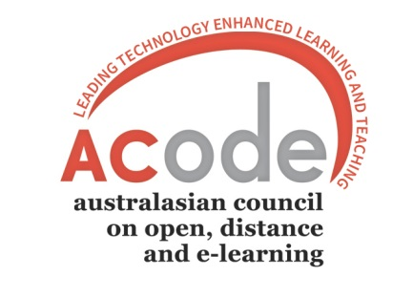

ACODE 2016

ANNUAL GENERAL MEETING Minutes

9.00-9.30am Friday 18th November 2016
University of Sydney – Fisher Library Meeting Room 249-250
PART A: PRELIMINARY BUSINESS
- Attendance and Apologies
Welcome:
Miriam Bennett – Victoria University
Aliya Steed ANU
Sam Parker CSU
Monica Cimolin – La Trobe
Attendees:
Auckland University of Technology Mark Northover
Australian Catholic University Veronica Hendriks
Australian National University Jenny Edwards
Australian National University Aliya Steed
Charles Sturt University Sam Parker
Flinders University Greg Faller
Griffith University Sheila McCarthy
La Trobe University Monika Cimolin
RMIT Michael Sankey
University of Adelaide Travis Cox
University of Auckland Steve Leichtweis
University of Canberra Karen Halley
University of Canberra Shane Nuessler
University of Canberra Jonathan Powles
University of Melbourne Deb Jones
University of the Sunshine Coast Ian Wright
University of Sydney Colin Lowe
University of Tasmania Gerry Kregor
University of Waikato Nigel Robertson
Victoria University Miriam Bennett
Victoria University Trish McCluskey
Victoria University Wellington Stephen Marshall
Western Sydney University Carol Russell

Apologies:
Philip Uys Charles Sturt University
Danny Munnerley James Cook University
Julie Fleming Central Queensland University
Jenny Pizzica University of Technology Sydney

- Minutes of previous Annual General Meeting - November 6th 2015 Adelaide
Moved……Michael Sankey………………………….. Seconded…Sheila McCarthy…………
3.0 *Identification of unstarred items for discussion
4.0 *Adoption of items not starred for discussion
MOTION: That all items on the Agenda not starred for discussion, be noted and where recommendations have been made, that these be adopted as resolutions of ACODE.
5.0 Matters arising from previous Annual General Meeting
PART B: ITEMS FOR DISCUSSION
6.0 Financial Reports On line.
6.1 2015 Auditor’s Report
6.2 2016 Profit & Loss Statement to date
7.0 Executive Officer’s Report
8.0 Declaration of election results
The President declared the results of the Election and explained that as we only had the 2 nominations for the positions there was not vote to be had.
Therefore we congratulate both Nigel Robertson (UoWaikato) and Philip Uys (CSU) on being re-elected to the Executive.

Meeting Closed 9.15 am

Stephen Marshall
President, ACODE

EXPLANATION
Note that the Agenda for this Annual General Meeting follows that proposed by the Executive in June 2003.
Unstarred items on the Agenda will not be discussed but any recommendations they contain will be covered by a single motion covering all unstarred items.
Any unstarred item may be identified for discussion by request to the President at any time up to item 4 on this agenda.
Please Note: Each member institution has one vote only. Members with affiliate status do not have voting rights, however are able to participate in discussion at the discretion of the President.

