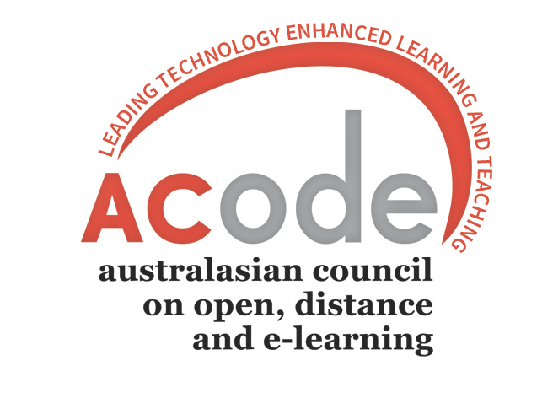 ACODE/CADAD
THURSDAY, 2 NOVEMBER 2017
Mereweather Surf House
5 Henderson Parade Mereweather Beach Newcastle
PROGRAM
Digital Assessment

THURSDAY, 2 NOVEMBER 2017

8:15-8:30  9.00 | Transportation from hotels to Merewether Surf House  Registration and coffee | Facilitator
9.30 | Welcome to Country  Welcome to University of Newcastle | Carol Miles,  Kevin Ashford-Rowe,  Stephen Marshall
9.45 | Session 1: Contract cheating in Australia: Implications for academic integrity: A/Prof Tracey Bretag, Associate Professor (Higher Education), University of South Australia Business School
11.00 | Morning tea
11.15 | Session 2: Designing Authentic Assessment workshop: Prof Carol Miles, Keith Foggett, University of Newcastle | Kevin  Kylie
1.00 | Lunch
1.45 | Session 3: CADAD/ACODE burning issues: Exam hacking and new academic integrity opportunities in a blended era: A/Prof Phil Dawson, Deakin University | Michael Sankey
3.15 | Afternoon Tea
3.30 | Bus transport to NeW Space  Session 4: NeW Space Tour | Carol Miles
4:00 | Reception and Address: Prof Darrell Evans, DVC Academic, University of Newcastle
5.00 | Close  Conference dinner:  6:30pm for 7pm Dinner, RUSTICA (2min walk from Noah’s)  2/1 King Street, Newcastle

